
Tak Sun Secondary School
Form 3 Integrated Science – Language exercise (1)
Class: _____ Class No.: _____ Name: ______________________________
Unit 4 Nutrition in human – teeth and physical digestion
1. Fold the page and write the English words in column 1 without looking.
2. Check if you are right. Fold the page again do the next column.
3. Repeat Step 2 until you can write all the words easily with no mistakes.

incisor |  |  |  |  | 門齒
cutting the food |  |  |  |  | 切食物
canine |  |  |  |  | 犬齒
tearing |  |  |  |  | 撕開
premolar |  |  |  |  | 小臼齒
molar |  |  |  |  | 大臼齒
grinding |  |  |  |  | 磨爛
teeth |  |  |  |  | 牙齒
chewing |  |  |  |  | 咀嚼
stomach |  |  |  |  | 胃部
churning |  |  |  |  | 攪拌作用
bile juice |  |  |  |  | 膽液
emulsify |  |  |  |  | 乳化
oil droplets |  |  |  |  | 小油滴
emulsification |  |  |  |  | 乳化作用
surface area |  |  |  |  | 表面積


Fill in the blanks.

1.
Type of teeth | Functions
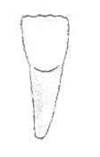  - ___________ | biting and (e) ___________ food
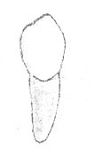  - ___________ | (f) ___________fresh
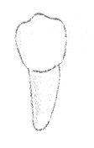  - ___________ | crushing and (g) ___________ food
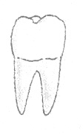  (d)___________ | crushing and (g) ___________ food

- In the mouth cavity, food is broken down into smaller pieces by the teeth, this step is called (a)_______________. It increases the (b)____________ _______ of food for digestive juice to work on.
- In the stomach, the food is further broken down by the muscular movement of the stomach, this movement is called ________________.
- Bile does not contain any enzyme but it can emulsify fat into small ______ _____________.

